From Yulia Berezhko-Kaminska (Невідворотне / Бережко-Камінська Юлія – К.: Саміт-книга, 2019. – 400 с.),
translated into English by Hanna O. Sheldahayeva (Petrenko)

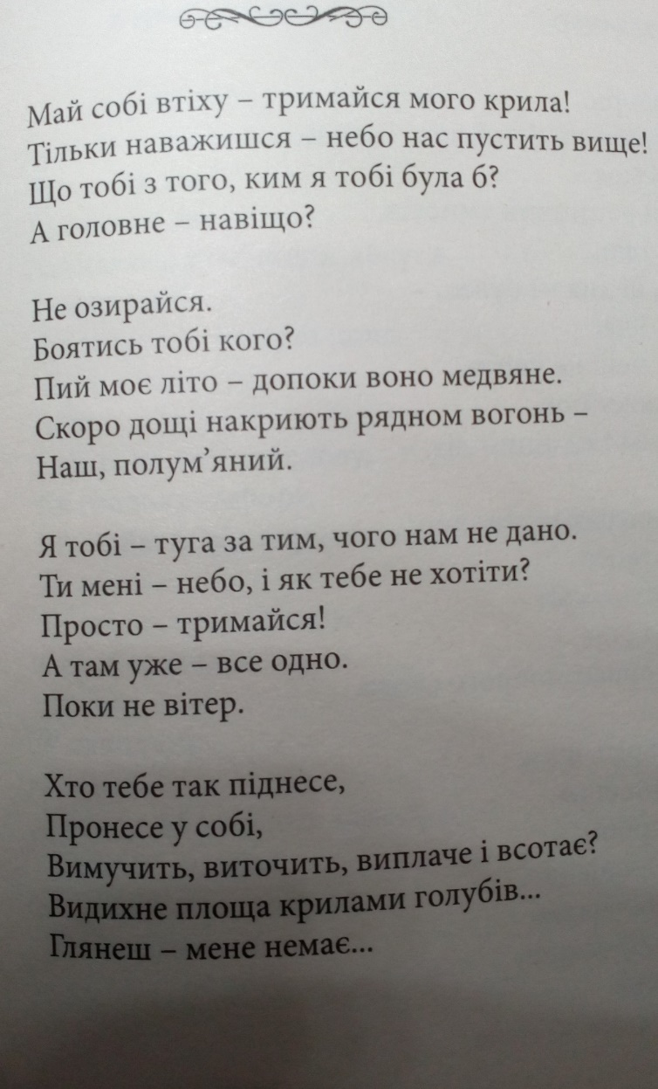
***
Accept it as comfort. You hold me tight by the wing!
As soon as you dare, our heaven will lift us higher...
To ask who I could be to you is a useless thing...
And what for, I wonder?

Why look back? There's no-one to be scared of...
Get steeped in my summer as long as it's filled with honey.
The rains... They will soon a wet blanket drop
On our fervent fire.

I am your pain for all that we’ll never have got…
You are my skies... I cannot but fly, you know...
Simply hold on. And then - no matter what...
The wind will soon blow.

Who else will absorb you, conceive you, and carry,
And raise you so high?
Torture and bear?
The square'll exhale the doves' wings into the sky -
You’ll look... But I won't be there...

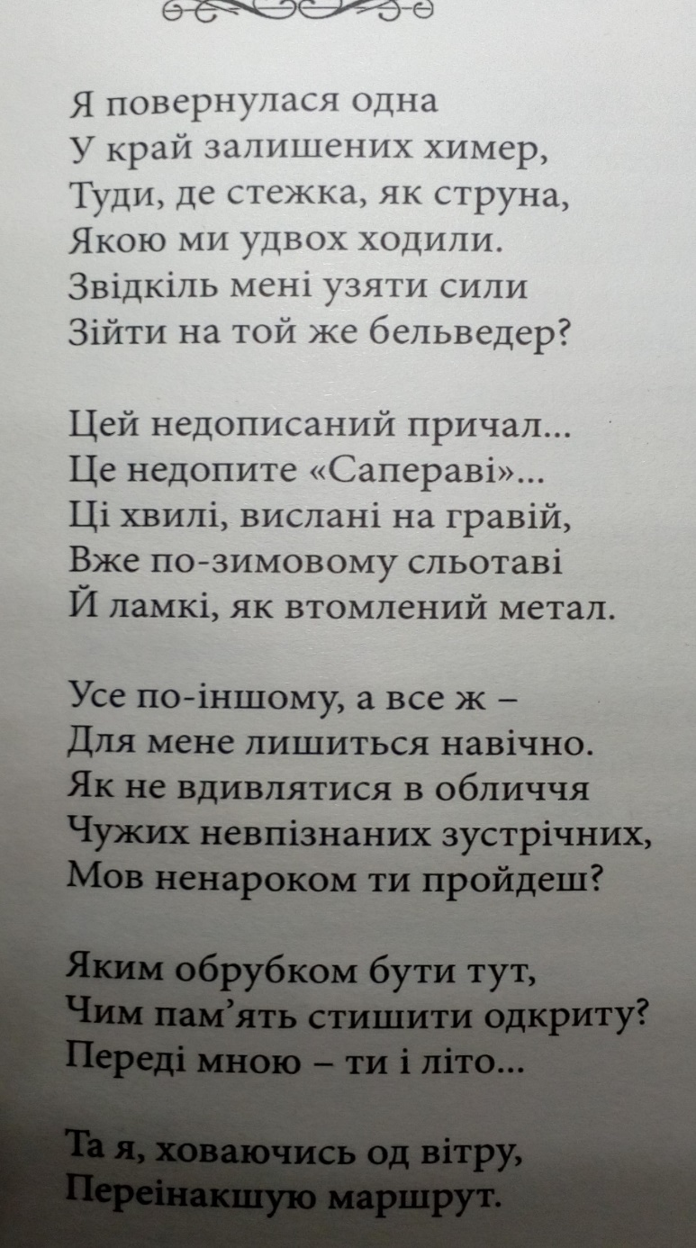
***
It is my lonely return.
I can behold the path so dear –
We walked together all its length!
Oh, can I find the very strength
To face the land of dreams forlorn,
Ascend the old belvedere?

A sight with an unfinished pier,
Expensive wine we left untapped…
The autumn waves on pebbles thrown
With a sleety touch – and under toes
They crack like worn out metal traps.

It’s all so different now – and mine…
You’ve left it all to me forever.
But how can I trust that never
I’ll see your eyes among the crowd
Of tens and tens of passers-by?
And you, by chance, may greet me loud…

What stump deformed should I here be?
How bury memory so bright
Of you and me in summer light?
I wrap myself to oust the wind,
And choose a different route tonight.

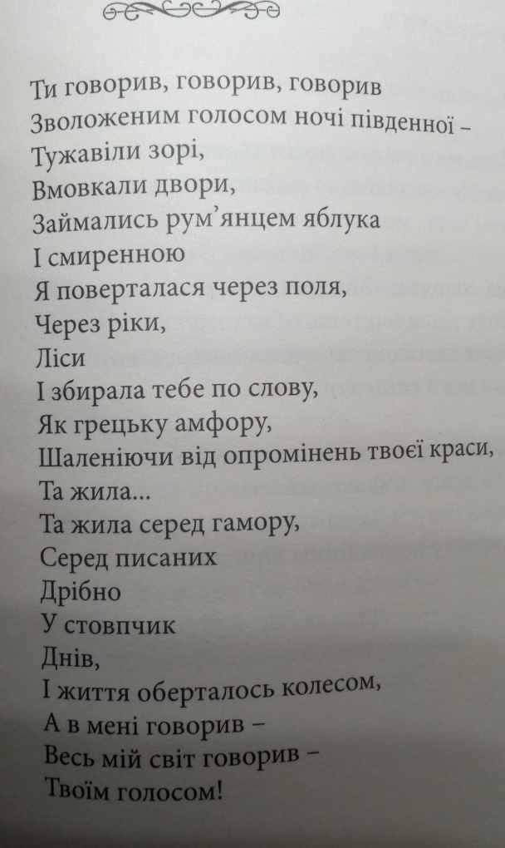
***
You had spoken, and spoken, and spoken
With a moist voice of a southern night.
The stars froze.
The courtyards silenced.
The apples’ cheeks flushed in the darkness.
And humbled
I was returning across the fields,
The rivers,
The woods.
I was assembling you word by word –
As if you were a Greek amphora,
Ancient, found in parts…
The light your face had emitted stunned my mind,
And I lived…
I lived in the fuss,
In the columns of days
Printed in tiny figures.
As life went round the clock,
It spoke in me –
The whole world spoke in me –
With your voice!

